**WEB DEVELOPMENT**

1.What is internet?

2.How to make dummy server ? using Live Server Extension.

**HTML**

1. Heading tags- h1 , h2 , h3 , h4 , h5, h6.
2. In vs code , we can do “format document ” for the proper alignment of the code
3. Favicon.ico – try to get a title image
4. Lorem100 – it will write 100 words
5. Width:100% , isse overflow nhi hota
6. Max-width:600px , isse bda nhi hoga
7. <https://www.netlify.com/> yha pe website deploy hoti hai world wide
8. <hr> tag to horizonatl line
9. <a target="_blank" href="https:// "><b>graphical user</b></a>

Target blank is open to link in new tab

1. <br> add new line or give a break.
2. Shift + alt + down arrow – copy a line to next line
3. <ol type="A"> </ol>
4. HTML entities
5. Block element - <div> <p>
6. Inline -- <span> <i> <a>
7. Semantic tags-   
   DIV tags--<header><nav><footer><main><article><section><aside>
8. **Global and Custom Attributes**

**Global Attribute** - hidden , style , title(cursor rkhne par info deta hai), class= ” ” , id=” ” , data-

**Custom** – Saurabh=”verma”

1. **HTML FORMS**-

Isme phle link tak search hota hai , phir form me jo “action=’ ’ ” me wo add hota hai phir jo name attribute hota hai wo , phir jo search krte h wo

**Form is block element.**

**type=” ”**

**<button type=” “>**

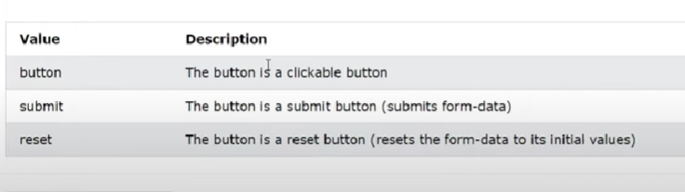

* THIS is called ROUTING in HTML

1. <a href="#css">CSS</a>

    <a href="#js">Java Script</a>

 <!-- agr hume usi page me kisi ka link dena hai toh hum aise krnge -->

Jaha pe bhi javascript ya css ho , wha pe id=”” jake css , js daal do , wo link hojyega

20.

1. <a href="">Go To Top </a>
2. <!-- but this will reload the page , not a right way -->
3. <a href="#">GO To THE TOP</a>
4. <!-- in this it will find a id , but will not able to find so it will move to top , in this page will not be reloaded -->
5. </body>
6. Atom one dark(extesnion)  
   material icon (extension)
7. Inline css-
8. <h1 style="color: brown;">Hello World </h1>
9. Internal CSS
10. <style>
11. p{
12. color: blue;
13. }
14. </style>
15. **User Agent Style sheet**

It is style sheet provide by the browser

Color picker eye dropper (chrome extension)

1. **CASCADING style sheet**

Specificity  
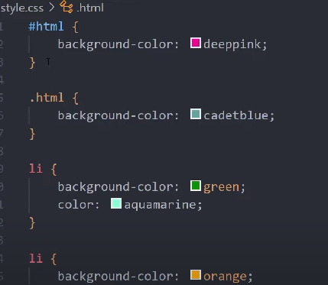

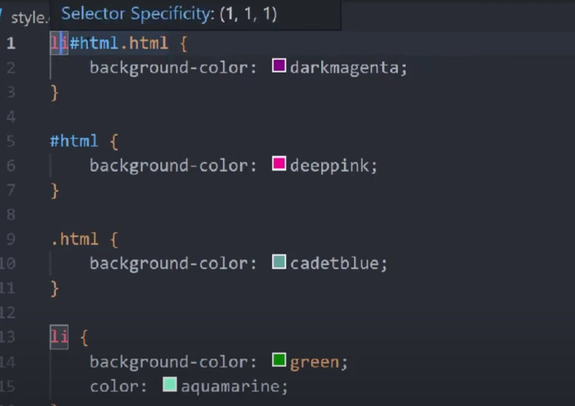Top of Form

This will increase the specificity.

  <link rel="stylesheet" href="style.css">

  <link rel="stylesheet" href="style2.css">

IN THIS style2.css wali hi active rehigi

  <link rel="stylesheet" href="style2.css">

  <link rel="stylesheet" href="style.css">

IN THIS style.css wali hi active rehigi

**INHERITANCE-**

In this , jese <body> tag me kuch color:blue kia

To body k andr jobhi <p> <div > , <ol>,<ul> hoga uska color bhi change hoga

But **Inheritance** zaroori nhi ki hoga , kuch exceptions bhi hote hai

Supoose body ke andr **<button>** tag hai

To button tag me inheritance nhi hoga.

But wo in real inherit hoti hai but user agent style sheet , wo inherit property ko over ride kr deta hai

Button me change krne k lie style.css me jakae button{color:blue} karna pdega.

Network me jake , jo inline style hoti hai , wo element.style me dikhti hai.

**inline style – ki specificity id se bhi jyada hota hai.**

**inline style ki specificity 1000 hoti hai.  
  
! Important – it has the highest specificity**

**Overflow-**

By default overflow ki property hoti hai **visible**

And other property hai , **hidden**

**Isllie width and height fix nhi krna chaiye**

**Max width ya height fix krna chaiye.**

**Jab min height fix krdi  
word-break: break-all;** jab overflow hota hai to word ko wo kahi se bhi break kar deta hai and content ko overflow nhi hone deta hai.

Jab hum **width- 50%** lete hai to wo parent se compare krke leta hai , naki browser width se

**Important—**

**Agr parent block ki width set kre ya ana kre  
child block ki width 50% krde toh width 50% hogi**

**But height k sath aisa nhi hota,  
hume parent block (ya fir parent ke parent ki..) ki height pixel me set karni pdegi agr hum child block ki height 50% of parent set krna h toh.**

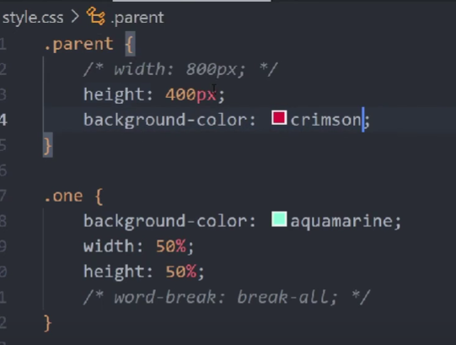

**PADDING-**

Content k har taraf space add krdeta hai , jisse ki width increase hojati hai, ya fir height increase hojati hai. **Border-**har taraf border add kr deta hai , color k sath

Aur overall width badha deta hai.

**Box-sizing: border- box**

Isme hum padding , border kitna bhi add kre but overall width same rehti hai .

Padding , border andar ki taraf increase hoti hai

Agr border , padding ki value bhut jyada increase krde tab height and width me change aata hai   
but in real hume bhut jyda increase kren ki zarurrat nhi padti

.container{

    width: 400px;

    height: 400px;

    background-color: rgb(228, 143, 143);

    padding: 20px;

    border: 50px solid red;

    box-sizing: border-box;

}

**UNIVERSAL SELECTOR**

*/* it is a UNIVERSAL SELECTOR , it applies on all the elements */*

*{

    box-sizing: border-box;

}

**MARGIN-**

Jo div ya block hota hai uske width ya height pe frq nhi aata hai ,

Margin hmesa uske bahar lgti hai , wo apne paas wale elemnt se kuch doori bna lega but jo block hai uska size same rhega.

**Body{margin:0;}** // body ka inbult margin hota hai user agent sheet me , wo zero hojyega

**<p>** tag me bhi margin hota hai

**<h1>** tag ka bhi margin hota hai

**Border radius-**

Isme ye zaroori nhi ki border:40px ya koi bhi random value ho border ki . Border zaroori nhi hai border radius k lie .

**Margin can be negative- try with border padding and etc with negative values.**

**OUTLINE-**

**Outline bhi border ki trh hota hai . wo bhi width nhi change krta hai .**

**Sabse imp ye ki jese hum width ya border badhte hai to aas pas wale element khisak jate hai agr wo bhut badh jata hui**

**But outline aisa nhi krta hai, wo khiskata nhi hai bulki upar chadh jata hai. Jese ki exmaple**



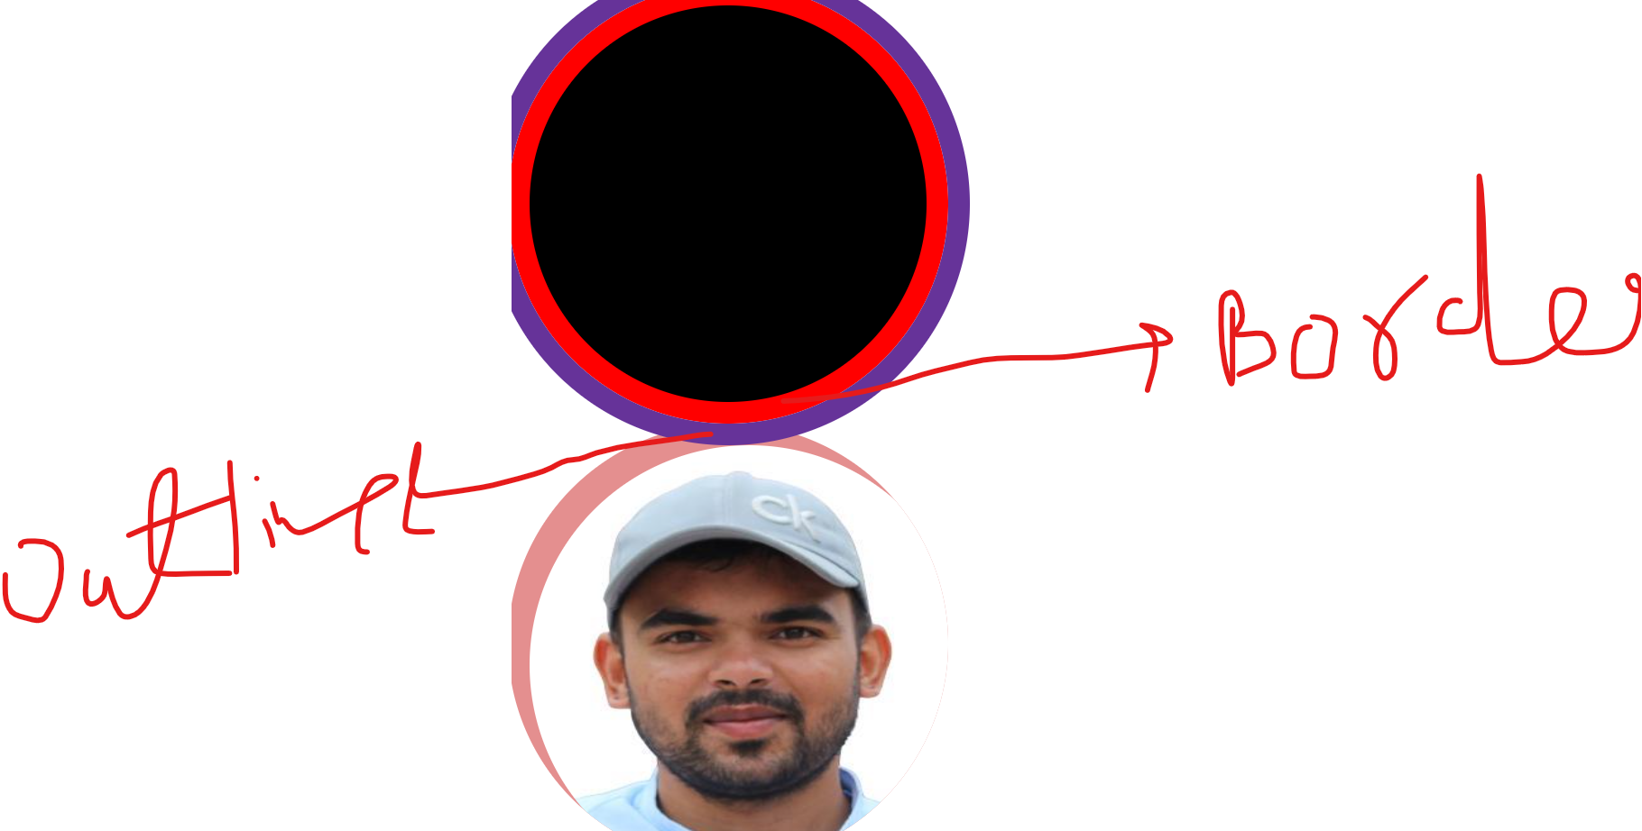

**INLINE ELEMENTS-**

<SPAN> inline elemnts pe **height** and **width** kaam nhi krti hai ,

Agr inline elemnt ko hum kuch bhi height ya width de to uspe apply nhi hogi.

But agr **padding** or **border** or **margin** de inline elements ko toh kaam kregi but kuch weird tarrke se ,

For e.g hum block element ki padding increase kre to wo neeche wale elemets ko push krega aur side me bhi

But inline elements ki **padding or border** **or** **margin** increase kre to wo doosre elemts ko upar chadh jati hai aur inline elemnts ki agr padding ya border increase kre toh wo side wise increase hote hai , **top or bottom se increase/decrease nhi hote**

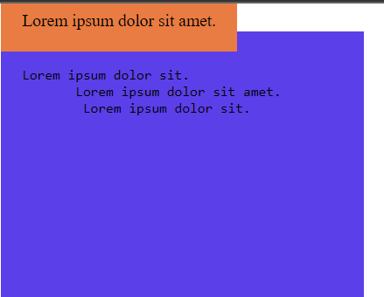

To aab inline ki problem ko door kese kre, isko kr skte hai

**Display-:**

**Display: inline / block / inline-block/none**

**Inline-** no width or height, padding and other property bas side wise apply hoti hai

**Inline block-** we can set width or height and it is also in same line, , padding and other property bas side wise and top and bottom bhi apply hoti hai, aur isme doosre element pe chadhta bhi nhi hai.

**Inline element 2 tarrke ke hote hai-**

* **Replaced-** <img>, <ifarme>,<video> isme hum height width set kr skte hai, isme padding border sab kaam krta hai , isko inline-block element jesa treat krna chaiye
* **Non replaced-** <a><span><b>

**Display:none** // is same as hidden and it will hide the data

SUMMARY of today session-

Summary :- 1. We use padding because to generate space around an element's content 2. Border by default color set as our text color, but we can overright it. 3. when we add padding & border the overral width of the box will increse , to avoid that we can use one property (box-sizing: border-box;) . 4. Margin will not affect our inner content. it apply in the outside of the box. 5. for making circle using border radius property, user should must apply width & height. 6. the outline is drawn outside the element's border, and may overlap other content. Also, the outline is NOT a part of the element's dimensions; the element's total width and height is not affected by the width of the outline*/ /* 1. In inline element, width & height doesn't workout. width & height dependend on inner content. 2. if we add padding & border in inline element it's overral height & width increses. 3. when padding & border applied to an inline element the top and bottom padding's affect the surrounding elements. 4. in inline elements, everything works inline, for top & buttom it doesn't work properly. 5. To avoid these type of problem, user should use display: inline-block. 5. There are two types of inline element, one is replaced another is non replaced. for replaced elements every property works properly even if the element is inline example -: <iframe>,<video>,<embed>,<img> non-replaced elements are as similar as inline elements. examples -: span, strong, i, b, em

**CSS UNITS-**

Phle to hume **width** deni nhi hai , agr deni bhi hai to **max -width** do.

**Width** – 50% is 50% of the parent element

**Height**- agr % me denge to kaam nhi krega , hume pixel me hi dena padta hai, but but but agr parent element ki height pixel me de , then hum inner elements ki height % me de skte hai.

**Padding**- isko bhi % me de skte hai aur iski padding parent elemnt k width ka % hota hai  
padding= width(of parent)*50%.

**Margin-** isko bhi % me de skte hai aur iski margin parent elemnt k width ka % hota hai  
margin= width(of parent)*50%.

**Font-size:** isko bhi % me de skte hai , aur ye parent k font-size se leta hai

**VW(View Port width)-** aab isme width:50vw

Mtlb ki 50% of the browser width hoga , hum parent ka kuch bhi width rkhe but vw humsa browser ki width ka 50% hoga.

**VH –** isme jo width hoti hai wo height of the browser pe depend krti hai.jese hi height of brower kam krneg width kam hogi aur jese increase krnge width increase hogi.

Hence by using VH and VW we can increase and decrease width , height , padding , border , margin.

Generally ,most of the element ke font size 16px hi hota hai , jese <div><><><>.

**EM- 1 em = 16px**

Sabse phle ye ki , agr parent block me font size = 30px hai , to agr child block me agr kuch font size define nhi dia hai toh child block wobhi 30px hi hoga.

Aab aate hai **em** pe,

**Parent block** – font size -20px

**Child block** – font size – 2em = 20px *2

**Parent block-** width 20px , font size – 10px

**Child block-**font size not define, width -2em=10px * 2 (2 time­s of font size of parent)

**Parent block-** width 20px , font size – 10px

**Child block-**font size-2em=10px*2=20px, width -2em=20px * 2=40px (2 times of font size of child)

**REM- 1 rem =16px**

Isme kuch parent child wala relationship nhi rehta hai , rem=constant

rem= font size of html(root elemnt)

koi bhi element ho web page ka agr rem dia hai to wo constant hai

2rem = 2* font size of html.

Agr rem ki value change karni hai to phir

Html{ font-size:30px}

1rem=30px hogya aab

**POSITION**

BY default sab elements ki position : static hoti hai.

div{

    background-color: chartreuse;

    position: relative;

    bottom: 50px;

    top: 50px;

}

Bottom and top dono define hai toh is case me top wala hi kaam krega kyonki top ki priority jyada hai shyd se.

Isi trh right or left me , left ko jyada priority dete hai

div{

    background-color: chartreuse;

    position: relative;

    bottom: 50000px;

    top: 300px;

}

**Position**:relative

Relative to the static position . mtlb ki jobhi movement hum denge left, right , up , down wo relataive to static position hoga.

Fact::Aab dekho ki jab hum left bhut jyda de dete hai toh scroll bar aata hai, right me nhi aata hai

But agr top and bottom bhut jyda hojata hai toh , scroll bar nhi aata.

**Inset: 5px;** ka mtllb hot hai🡪

Top =5px , right=5px , bottom=5px ,left=5px

**Position:** Absolute

Ye similar hota hai , delete krne ke barabar.

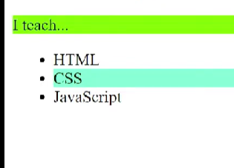

Position:absolute

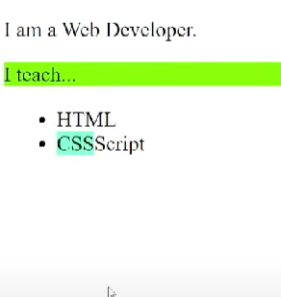

Ek toh isme neeche wala content upar khisak jata hai , aur sath me over all height bhi kam hojati hai , us block ki.

Position : absolute – aisa hota hai ki , wo kehta hai mai hu yhi pe , par gayab hogya hu

Position:absolute

Top:5px;

Bottom:5px

Isme hum log top or bottom dono apply kr skte hai , jisse ki iski height badh jati hai

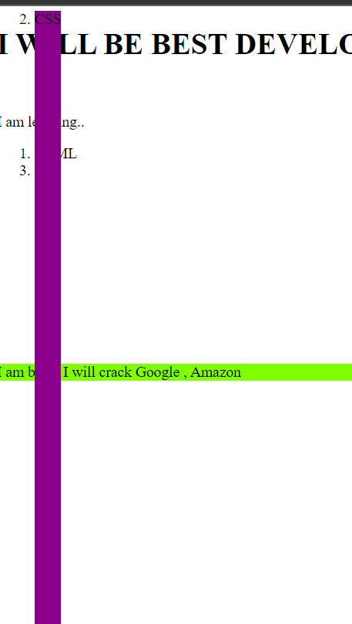

Position:absolute

Top:5px;

left:5px

right:5px

isme dono property left and right dono kaam krti hai ek sath, jisse ki overall width incrase hojati hai.

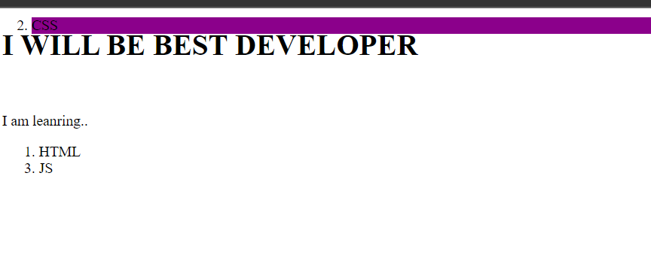

Jese ki humne dekha tha ki **Position :relative** me hum top or left de rh the to wo apne original position se move kr rh tha.  
but **position:absolute** agr dedete hai ,kisi element ko aur parent element me kuch bhi nhi hai position mtlb ki parent me position:static hai toh , **position:absolute** ka reference point browser ke top left corner se hoga.

Agr **position:absolute** hai aur agr iske parent ya grand-parent k paas

**position:** absolute /fixed/sticky ya kuch bhi ho static ko chor ke toh ,wo element parent ya grand-parent ke sath attach hojat hai.

Aisa nhi ki absolute position wala element bahar nhi jayega , agr top:10000px dede to bahar jayega but still wo parent se attach rhega ,

**Position:** Fixed-

Ye bhi absolute jese behave krta hai – jese ki width kam hojna aur aisa behave krta hai ki gayab hogya hai.

Ye hmesa always view port (browser se hi connected rehga) chahe parent relative /sticky/absolute ya kuch bhi ho

Position:absolute/fixed – isko bolte hai ki , ye normal flow of document se bahar aagya hai

**Position:sticky**

Ye edkm relative ki tarh behave krta hai,

Ye apne position pe rehta hai aur , document k flow k bahar bhi nhi jata hai.

Isme width bhi kam nhi hoti just parent elment ki.

Postion:sticky krne par , jobhi element pe sticky lga rehta hai , chahe kuch hojaye wo parent element ke andr rhta hai . chahe top ya left pixel kuch bhi define krde.

.sticky{

    background-color: rgb(193, 31, 193);

    position: sticky;

    top: 50px;

}

Ye abhi kaam nhi krega , hume output me kuch difference nazar nhi ayega

Kyonki humne abhi parent element me overflow:scroll define nhi kia.

ol{

    background-color: khaki;

    height: 500px;

    overflow: scroll;

}

Ab hume difference nazar ayega.

ol{

    background-color: khaki;

    height: 500px;

*/* overflow: scroll; */*

    margin-top: -10px;

    position: relative;

}

.sticky{

    background-color: rgb(193, 31, 193);

    position: sticky;

    top: 50px;

}

Agar hum <ol> ki margin-top change kre toh , jyada agr negative hoga toh wo browser se 50px maintain krke chlega , aur end me jyada negative hoga toh <ol > ke end me aake usi <ol> k sath chla jyega.

Position:sticky parent k parent k parent ………me jake overflow:scroll search krta hai , agar use kahi nhi milta hai toh , wo browser k top se khud ko shift krleta hai.

# Transform, Translate, Transition, Shadows, Opacity, Alpha Channel |

**Transform:scale**

Transform:scale(1.5); isme kya hota hai ki , maan lo ki div element lia aur usme box bna dia , agr usko Transform:scale(1.5); kre toh size increase hojyega us box k centre se , agr aaas paas kuch elemnt hue to wo unko push nhi krega balki overlap krdega .

Aur sabse important baat , isme jo box hai , agr usko inspect krke dekhoge toh pta padega ki – uski width aur height increase nhi ho rh hai .

Abhi humne discuss kia tha ki , box ka size increase center se ho rh hai but hume corner se chaiye increase , mtlb jo refrence point ho , wo corner ho.

[Grab your reader’s attention with a great quote from the document or use this space to emphasize a key point. To place this text box anywhere on the page, just drag it.]

50% , 50%

Phle by default –

Transform-origin:50% 50%

Now we want to increase from the left top corner.

Transform-origin:0 0 ;

**Alpha Channel**

background-color: hsla(43, 89%, 38%, 0.356);

0.356 is called Alpha channel.it contains opacity , but it is not similar to opacity.

**Alpha channel vs Opacity-**

Opacity -

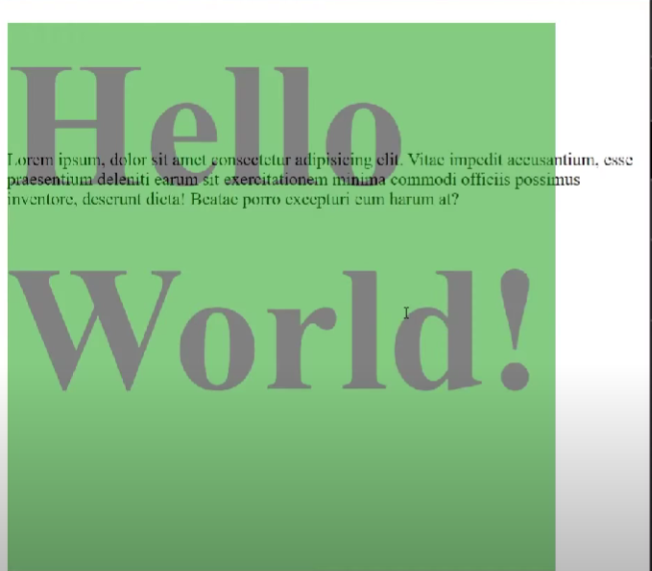

Alpha channel-

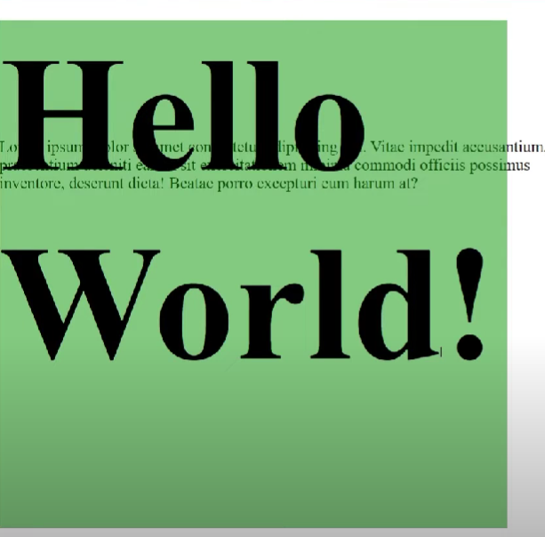

Toh alpha channer se sirf background color ki opacity kam hotu hai but opacity se jobhi content hota hai block me , for e,g text ya kuch bhi uski opacity bhi kam hojati hai

**Transform:rotate()**

Transform:rotate(45deg)

Transform:rotate(-45deg)

Ye bas rotate krne k lie use hota hai

**Transform: translate();**

 transform: translate(400px);

ye content ko left ya right and up and down move krta hai , jese ki margin jese, but isme khaas baat ye hai kiTransform: translate(); content ko push nhi krta hai , balki margin krdeta hai.

 transform: rotate(45deg);

    transform: translate(400px);

    transform: rotate(45deg);

abhi mene notice kia ki ye dono property ek sath kaam nhi krti hai , jo neeche hoti hai wo kaam krti hai.

Transform:translateY(100%);

100% ka mtlb hai ki wo apne height ya width ka barabar move krega.

5m 5m

**Pre position new position**

**translateX(100%)- isme box apne width ke barabr move kia hai**

**How to center a <div> ;Method:1:**

 position: fixed;

    margin: auto;

    inset: 0;

## **How to center a <div> Method -2**

img{

  display:block;

  margin-left:auto;

  margin-right:auto;}

For the styling of the page to look similar on mobile as it does on a desktop or laptop, you need to add a meta element with a special content attribute.

Add the following within the head element:

<meta name="viewport" content="width=device-width, initial-scale=1.0" />

**alt**